Создание БД
CREATE DATABASE sports_competition_db
ENCODING = 'UTF8'
LC_COLLATE = 'ru_RU.UTF-8'
LC_CTYPE = 'ru_RU.UTF-8'
TEMPLATE = template0;
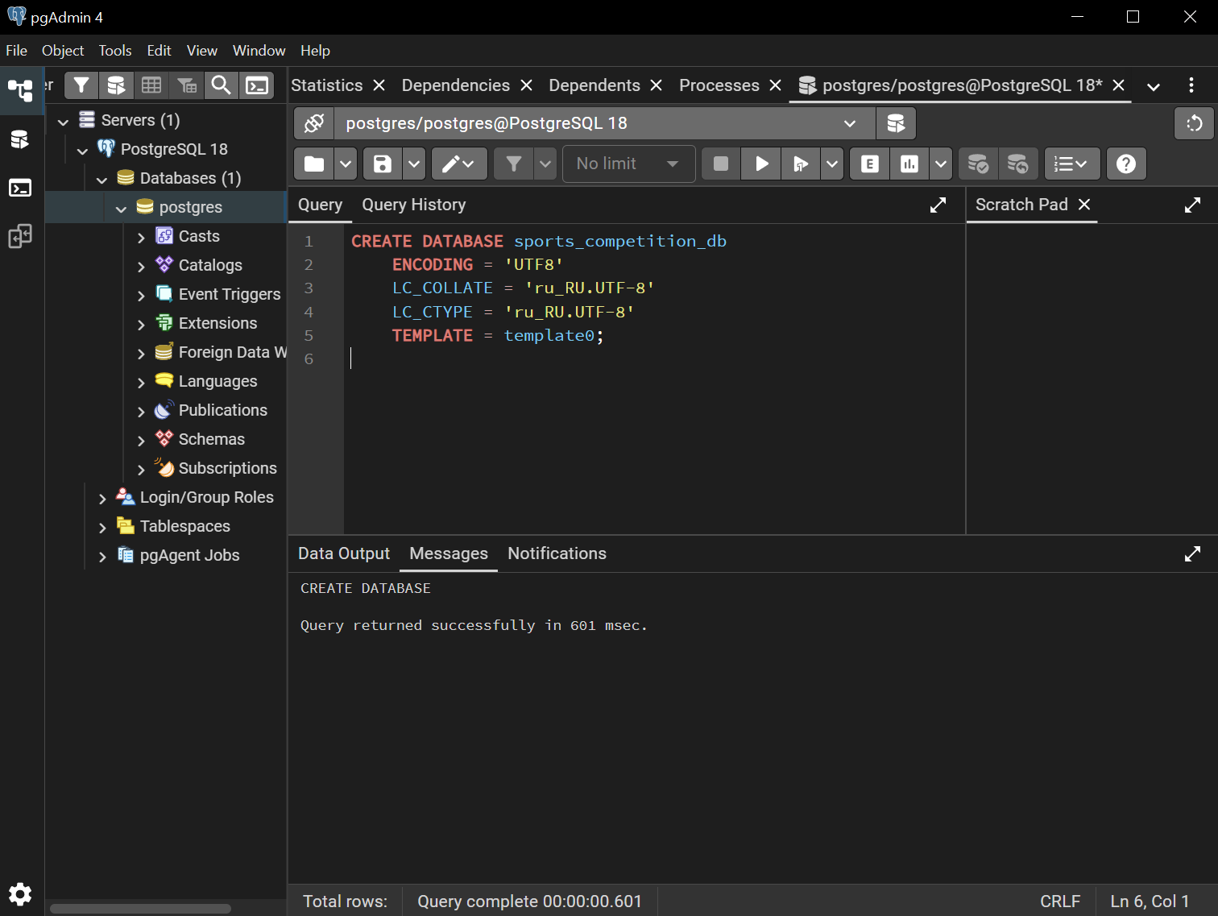

Создание таблиц
CREATE TABLE cities (
city_id SERIAL PRIMARY KEY,
name VARCHAR(100) NOT NULL
);

CREATE TABLE sports_types (
sport_type_id SERIAL PRIMARY KEY,
name VARCHAR(100) NOT NULL
);

CREATE TABLE disciplines (
discipline_id SERIAL PRIMARY KEY,
name VARCHAR(100) NOT NULL,
sport_type_id INT NOT NULL,
CONSTRAINT fk_disciplines_sport_type FOREIGN KEY (sport_type_id)
REFERENCES sports_types(sport_type_id)
ON UPDATE CASCADE ON DELETE RESTRICT
);

CREATE TABLE venues (
venue_id SERIAL PRIMARY KEY,
name VARCHAR(100) NOT NULL,
city_id INT NOT NULL,
capacity INT,
CONSTRAINT fk_venues_city FOREIGN KEY (city_id)
REFERENCES cities(city_id)
ON UPDATE CASCADE ON DELETE RESTRICT
);

CREATE TABLE sports_organizations (
organization_id SERIAL PRIMARY KEY,
name VARCHAR(100) NOT NULL,
city_id INT NOT NULL,
type VARCHAR(50),
CONSTRAINT fk_organizations_city FOREIGN KEY (city_id)
REFERENCES cities(city_id)
ON UPDATE CASCADE ON DELETE RESTRICT
);

CREATE TABLE participants (
participant_id SERIAL PRIMARY KEY,
full_name VARCHAR(100) NOT NULL,
birth_date DATE,
gender CHAR(1) CHECK (gender IN ('M', 'F')),
organization_id INT NOT NULL,
CONSTRAINT fk_participants_organization FOREIGN KEY (organization_id)
REFERENCES sports_organizations(organization_id)
ON UPDATE CASCADE ON DELETE RESTRICT
);

CREATE TABLE competitions (
competition_id SERIAL PRIMARY KEY,
name VARCHAR(150) NOT NULL,
start_date DATE NOT NULL,
end_date DATE NOT NULL,
city_id INT NOT NULL,
status VARCHAR(20) DEFAULT 'planned',
CONSTRAINT fk_competitions_city FOREIGN KEY (city_id)
REFERENCES cities(city_id)
ON UPDATE CASCADE ON DELETE RESTRICT,
CONSTRAINT chk_dates CHECK (end_date >= start_date)
);

CREATE TABLE competition_venues (
competition_id INT NOT NULL,
venue_id INT NOT NULL,
start_time TIMESTAMP NOT NULL,
end_time TIMESTAMP NOT NULL,
PRIMARY KEY (competition_id, venue_id),
CONSTRAINT fk_comp_ven_competition FOREIGN KEY (competition_id)
REFERENCES competitions(competition_id)
ON UPDATE CASCADE ON DELETE CASCADE,
CONSTRAINT fk_comp_ven_venue FOREIGN KEY (venue_id)
REFERENCES venues(venue_id)
ON UPDATE CASCADE ON DELETE RESTRICT,
CONSTRAINT chk_times CHECK (end_time > start_time)
);

CREATE TABLE results (
result_id SERIAL PRIMARY KEY,
competition_id INT NOT NULL,
discipline_id INT NOT NULL,
participant_id INT NOT NULL,
place INT,
result_value VARCHAR(50),
date DATE NOT NULL,
CONSTRAINT fk_results_competition FOREIGN KEY (competition_id)
REFERENCES competitions(competition_id)
ON UPDATE CASCADE ON DELETE CASCADE,
CONSTRAINT fk_results_discipline FOREIGN KEY (discipline_id)
REFERENCES disciplines(discipline_id)
ON UPDATE CASCADE ON DELETE RESTRICT,
CONSTRAINT fk_results_participant FOREIGN KEY (participant_id)
REFERENCES participants(participant_id)
ON UPDATE CASCADE ON DELETE RESTRICT,
CONSTRAINT chk_place CHECK (place IS NULL OR place > 0)
);

CREATE TABLE referee_roles (
role_id SERIAL PRIMARY KEY,
name VARCHAR(50) NOT NULL
);

CREATE TABLE referees (
referee_id SERIAL PRIMARY KEY,
full_name VARCHAR(100) NOT NULL,
category VARCHAR(50),
organization_id INT NOT NULL,
CONSTRAINT fk_referees_organization FOREIGN KEY (organization_id)
REFERENCES sports_organizations(organization_id)
ON UPDATE CASCADE ON DELETE RESTRICT
);

CREATE TABLE referee_assignments (
assignment_id SERIAL PRIMARY KEY,
competition_id INT NOT NULL,
discipline_id INT NOT NULL,
referee_id INT NOT NULL,
role_id INT NOT NULL,
CONSTRAINT fk_assign_competition FOREIGN KEY (competition_id)
REFERENCES competitions(competition_id)
ON UPDATE CASCADE ON DELETE CASCADE,
CONSTRAINT fk_assign_discipline FOREIGN KEY (discipline_id)
REFERENCES disciplines(discipline_id)
ON UPDATE CASCADE ON DELETE RESTRICT,
CONSTRAINT fk_assign_referee FOREIGN KEY (referee_id)
REFERENCES referees(referee_id)
ON UPDATE CASCADE ON DELETE RESTRICT,
CONSTRAINT fk_assign_role FOREIGN KEY (role_id)
REFERENCES referee_roles(role_id)
ON UPDATE CASCADE ON DELETE RESTRICT
);

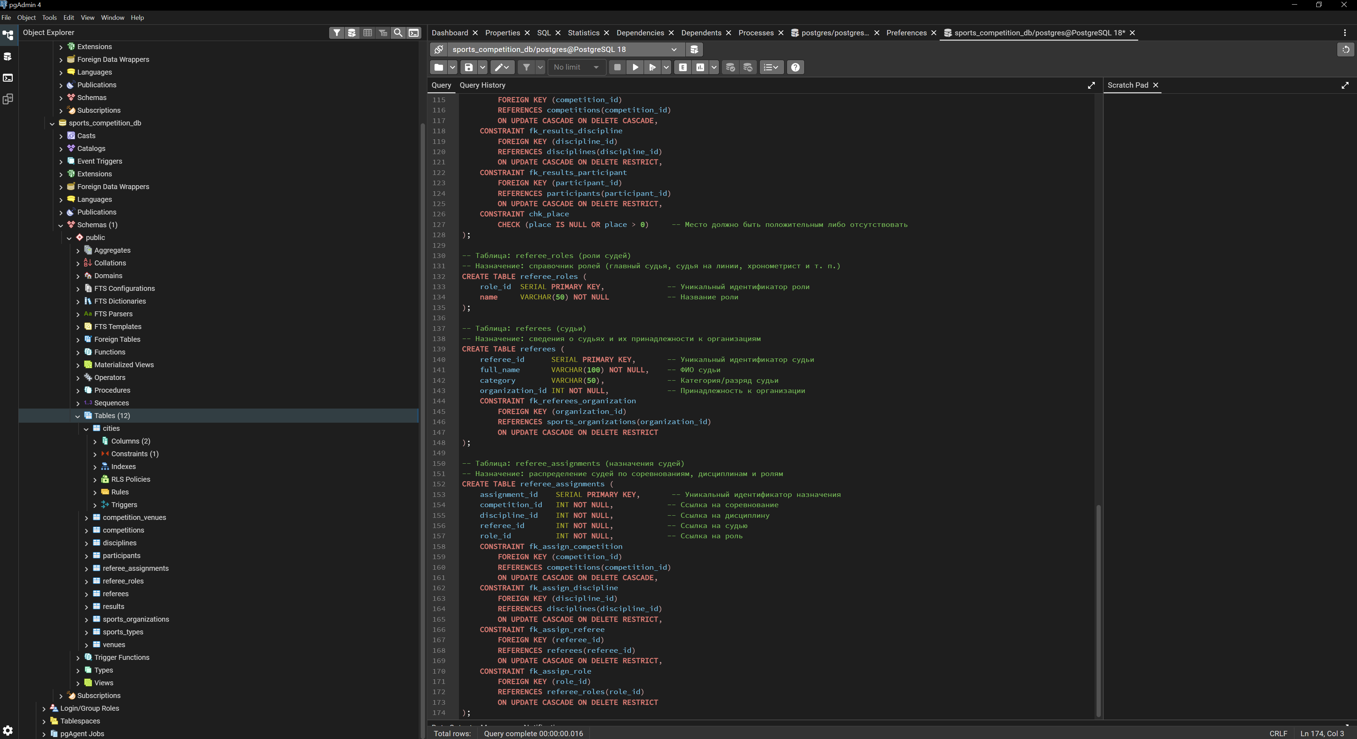

EDR
